Needs Assessment: Prisoner Reentry Therapy Programs in Washington State- Art and Music Therapy Program Proposal

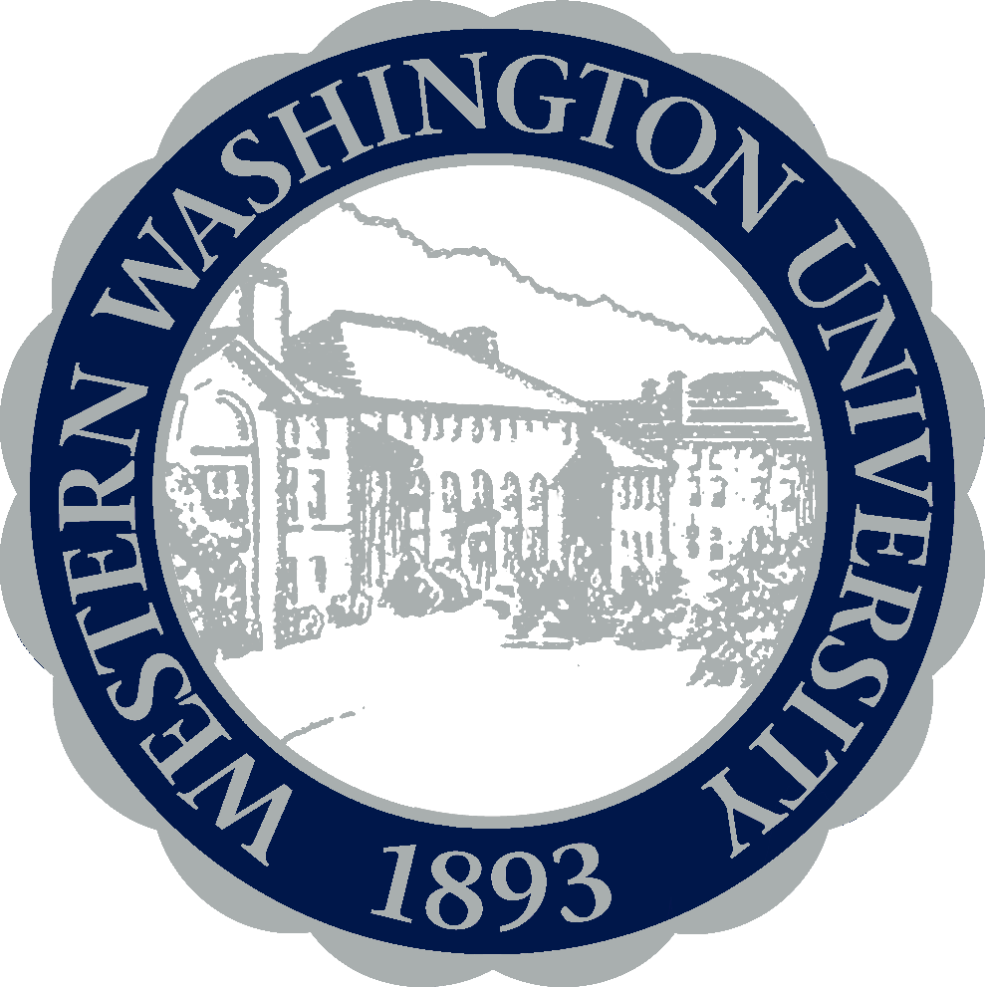

Mallory Dudley
Western Washington University
HSP 495 Capstone Portfolio
May 24, 2016
Executive Summary

Prison Reentry Therapy Purpose:
Adults transitioning out of jail and prison, with almost half of them experiencing mental illness symptoms, are facing additional stress learning how to support themselves outside of jail and reenter into their communities. Washington State, among the other states, incarcerates a large number of people in correctional facilities and there is a high risk of developing mental health symptoms. While this population undergoes a high amount of stress after being in jail, is not prepared to reenter society, especially with a criminal history and no assistance to find housing, education, and employment. The Department of Corrections recidivism rates in Washington State from 2006 show 31.1 percent, a decline since 2003 (Washington State DOC, 2010). With these high rates of recidivism, nationally about 20 percent of these inmates in jail and 15 percent in state prisons have a serious mental illness (Treatment Advocacy Center, 2014). Throughout Washington State, there are very few reentry programs, let alone any support or assistance for prisoners being released. The reentry programs that are offered, other than the Department of Corrections and probation, are nonprofit organizations that handle a large number of clients such as Pioneer Human Services in Seattle, or state run projects. Although there are 12 correctional facilities in Washington state, there are few nonprofit and government programs that provide programs, job training, education, mental health and chemical dependency treatment and counseling for the people in these facilities. While correctional facilities offer vocational education, trade skills training, and mock job interviews, there are no alternative therapy and counseling services for this population besides services provided by the nonprofit organizations.

The Target Population:
The population will include prisoners that have been released from Washington State prison and jail in the last five years that have mental health needs. The demographics include recent prisoners, with a disproportionate percentage of African-American and Latino incarcerated peoples in Washington and across the country, including low-income populations, and individuals with mental illness that are reentering their communities from jail and prison. As mental health needs and medical attention is not being addressed or treated, the risk for recidivism increases for ex-offenders with mental illness (Washington State Department of Corrections, 2010).

Barriers:
Although there is continuing education and knowledge on mental illness, there are very few programs and research done on creative art therapies, especially within the prison population, and the results or benefits of these therapies. However, some research has been done to study the effectiveness of art therapy in prison, and it’s reduction of depressive symptoms (Gussak, 2007). Research will have to be done in Washington State to study the effectiveness of art and music therapy on prison and ex-offender programs within the mental health unit to determine any change of recidivism rates.
The barriers of starting the art and music therapy program will include research, funding, and expansion of current programs. This program will hopefully be presented by the Department of Corrections, as a government run program that can be offered to all prisoners across the state. As the Washington State Correctional Industries provide work training programs and vocational education, these mental health creative therapies can be incorporated in order to prevent recidivism, meet their mission, and better the lives of the population when they are released from correctional facilities.

Needs Identification/Assessment:
With a large population of incarcerated adults in the United States, there is little being done to help them when they transition out of prison. With the concentration of education and employment, there is no collective concern for health and well being. The general national number of untreated mental illness is around 45% for the general population (National Institute of Mental Health, 2010). When we consider the 41% of prisoners reported to have a mental illness in Washington State, we know they are not receiving counseling and therapy, at least until they get out. That is a large number of untreated mental illness, and a large number of people who are not prepared to reenter their communities when faced with stress and anxiety.

Mission statement:
To improve the mental health and well being of those reentering society from jail and prison through creative therapy to ensure a healthy, productive life.

Program Goal:
Provide an effective counseling strategy through art and music therapy for adults that are transitioning out of jail and prison with mental health needs in Washington state; therapy that provides healing and creativity to improve their mental health by reducing symptoms of anxiety, depression, and stress.

Key Objectives:
- To evaluate existing reentry programs and develop a more inclusive model that offers more programs for ex-offenders.
- To allocate existing therapy services in Whatcom, King, and Pierce County and make them readily available.
- To provide new, insightful, and creative therapy for ex-offenders who are dealing with mental illness.
- Develop the best routine therapy program for each client in hopes of dealing with stress, anxiety, and depression symptoms.

Methodology:
There will be two focus groups held regarding the need for mental health services (creative therapy) for ex-offenders. Focus group #1 will be held with Pioneer Human Services of Seattle, Washington. Mental health counselors, therapists, and general staff from Pioneer Human Services will meet along with staff from the Seattle Department of Corrections. This meeting will address the ways Pioneer Human Services runs their mental health counseling unit to use as an example for the upcoming program. The group will discuss how to incorporate therapy into a government program for adults that are currently in jail and prison, and also for those who are being released. This focus group will address ideas in how to offer and implement art and music therapy, along with other creative therapy options, with Pioneer Human Services and how to use their model for a government run program. Focus group #2 will be held at the Seattle Corrections Department and will be open to ex-offenders who have experienced being in a state jail or federal prison in the last five years of their life. This discussion will address the health needs of inmates regarding physical, emotional, and psychological health, to learn how to better accommodate them. Questions will be asked regarding their interest level in art and music therapy, other drama/dance therapies, and traditional spoken therapy.

Limitations:
The limitations of this study and to learn the general needs will only cover a small portion of Washington State, and even a small part of Seattle. However this will appropriately meet the goals for a new program proposal, as Seattle is a large city and central location to start the first art and music therapy program. The focus group is limited to Pioneer Human Services, the Seattle Department of Corrections, and Seattle ex-offenders in the local community, whereas this only reaches and represents a small portion of the population we are trying to serve. The process of research, focus groups, proposals, and implementation of the program will utilize lots of time and resources and will limit the program outcomes.

Program Description:
Art and music therapy as a mental health counseling tool can provide alternative creative and innovative methods in lieu of traditional spoken therapy. This creative therapy program is offered to any person who qualifies for mental health counseling and is currently in or transitioning out of jail and prison. As a state wide public correctional program, every person with any mental health symptoms will qualify to participate or enroll in art and music therapy during this time.
This art and music therapy program, brought to you through the Seattle Corrections Department, will create a relaxing, therapeutic environment through painting and drawing, sculpting, drumming circles, community choir, and individual listening sessions that will reduce symptoms of stress, anxiety, and depression. A clinical professional for both art and music will work full time with clients. This includes weekly group therapy and/or individual therapy that will cater to the identified needs of the client.

Music Therapy is a clinical use of music interventions, accomplishes individualized goals within a therapeutic relationship with a credentialed music therapy professional (American Music Therapy Association, 2016).

Music Therapy is offered as group therapy sessions, including:
- Community Choir
- Drumming Circles
- Group Listening Activities
- Keyboarding
Individual sessions include:
- Individual keyboard lessons
- Meditative listening
- Singing lessons

Art Therapy is a mental health method that uses art media and a creative process to reduce anxiety and foster emotional, mental health, and well being (American Art Therapy Association, 2016).

Art therapy classes include:
- Canvas Painting
- Drawing
- Sculpting
- Listening/drawing activities

Art and Music Therapy Proposal:
To implement this new therapy program, a program committee will have to be formed to develop plans for the actual program, materials and employees needed. A program model will be prepared if able to receive the funds, and will be implemented by the professional therapists, volunteers, and committee.

Resources and Funding:
To establish this new government program, we will need to receive government funding to provide salaries, equipment and materials, space, and advertise to clients. Those that are enrolled in reentry programs for housing, education, or job training will be provided with brochures and information about the art and music therapy program.

- Human resources: One full time art therapist and one full time music therapist, 1-2 support staff for program development and planning, and 1-2 possible volunteer assistants.
- Financial resources: Program seed funds, grants, operating budget, salaries, and materials.
- Space: Office and community room, approximately 1,000 square feet, for group sessions and storing materials.
- Equipment/materials: Office supplies, art materials (paint, brushes, canvas, pencils, etc.), basic sound system, basic musical instruments (percussion), and possible additional instruments (keyboard, guitar).
- Marketing: Advertise the therapy program on Pioneer Human Services website along with provide brochures, flyers, and an online registration option.

Goal: To provide an effective counseling strategy through art and music therapy for adults that are transitioning out of jail and prison with mental health needs.
Resources  We will need the following resources to implement this plan (see table above) | Activities  In order to address our problem we will accomplish the following activities | Outputs  We expect that if accomplished, the activities will lead to the following tangible products | Outcomes  We expect that if accomplished, the activities will lead to the following changes | Overarching Goal  We expect that if accomplished, these activities will lead to this goal and have this impact
Human Resources/funding | Receive government funding: hire a professional music therapist, art therapist, and gather support staff | A new state wide music and art therapy program will be formed as a counseling tool | This program can become a regularly used therapy model for government run reentry programs | Music and art therapy will reduce stress, anxiety, and depression for clients with mental health needs
Human Resources | Establish a group therapy curriculum and schedule with therapists and support staff | Clients can rely on regular and planned therapy sessions | Regular planned therapy will be enjoyable, relaxing, and meet our client’s mental health needs | Regular therapy will improve stress and anxiety levels of clients during this time through emotional healing
Human Resources | Train volunteers and support staff for therapy programs | Volunteers will be well trained on therapy methods to cater to client needs and assist the therapists | We will see a decrease in mental health symptoms such as anxiety and depression by at least 30% | Clients will be well supported to decrease their mental health symptoms through therapy
Materials and Marketing | Support staff will advertise for music and art therapy for Pioneer Human Services on their website | Information will be available and easily accessible for any mental health client to participate | An increase of at least 30% of mental health clients will use music and art therapy services as a result of seeing brochures, advertisements, and online registration | Clients will use easily accessed information to have autonomy over their therapy needs
Space | Find ~1,000 square foot room for group therapy session and storing materials | A regular space will be provided for therapists, clients, and support staff to collaborate art and music | The room will provide enough space for regular group activities and art and music supplies | Regular clients will feel safe, welcomed, and relaxed while in this environment

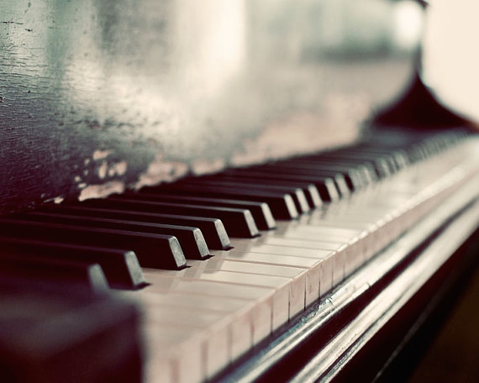

You are welcome to participate in our new art and music therapy program while you are in this period of transition. Art and music therapy will create a relaxing, therapeutic environment through painting and drawing, drumming circles, community choir, and individual listening sessions and will reduce symptoms of stress and anxiety that you may be facing. This includes weekly group therapy and/or individual therapy that will cater to your own needs. If traditional spoken therapy is not for you, try this new creative therapy and get the chance to express yourself through art and music!
Come join us!
Art and Music Therapy are offered as a statewide program in our Washington State Mental Health unit in Whatcom County, King County, and Pierce County.
Washington Locations:
- Seattle
- Tacoma
- Bellingham
You can register at:
Artandmusictherapy.wa.gov/jailreentry
Or call:
(206) 296-1234

500 5th Ave
Seattle, WA 98104
artandmusictherapy.wa.gov/jailreentry
Art and Music Therapy

Contact Us
Create in a therapeutic environment

Art & Music Therapy
  - Jail Reentry Program
  - Mental Health Counseling

Create in a therapeutic environment

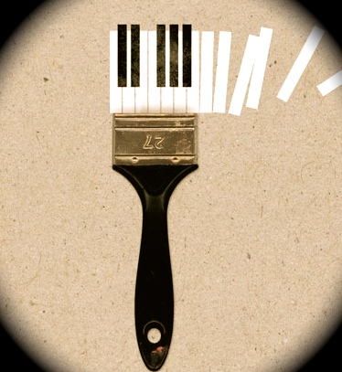
Music Therapy is a clinical use of music interventions accomplishes individualized goals within a therapeutic relationship with our credentialed music therapy professional.

Music Therapy is offered as group therapy sessions including:
- Community Choir
- Drumming Circles
- Group Listening Activities
- Keyboarding

Individual sessions include:
- Individual keyboard lessons
- Meditative listening
- Singing lessons
Art Therapy is a mental health method that uses art media and a creative process to reduce anxiety and foster emotional, mental health, and well-being.

Art Therapy classes include:
- Canvas painting
- Drawing
- Sculpting
- Listening/drawing activities

Each class is offered once a week and you can register for one individual session per week.
To find more information, visit us at:
Artandmusictherapy.wa.gov/jailreentry
Music Therapy

About
Art and Music Therapy is practiced in mental health and rehabilitation and is a mental health counseling tool for adults transitioning out of jail and prison in Washington State. These creative therapies can improve emotional, mental, and physical health through the reduction of anxiety and stress. Our clinical therapy professionals will get to know your individual needs and interests to best accommodate your lifestyle. If you have recently been released from a state or federal jail or prison, you will be able to register for art and music therapy or traditional spoken therapy/counseling. If you are interested in participating in group art and music therapy, the information is listed ahead with classes and contact information.
Art Therapy

References

Analysis of Statewide Adult Correctional Needs and Costs (Rep.). (n.d.). Retrieved May 23, 2016, from http://www.ofm.wa.gov/reports/Correctional_Needs_and_Costs_Study2014.pdf

Bunt, L. (1994). Music therapy: An art beyond words. London: Routledge.

City of Tacoma Mental Health and Chemical Dependency ... (n.d.). Retrieved May 24, 2016, from http://cms.cityoftacoma.org/hrhs/mentalhealth/CityofTacomaMHCDAssessmentfinal

The Dangerous Mentally Ill Offender Program: Four-Year Felony Recidivism and Cost Effectiveness (pp. 1-4, Rep. No. 09-02-1901). (n.d.). Retrieved May 23, 2016, from http://www.wsipp.wa.gov/ReportFile/1036

Evans, M. (n.d.). Washington State Department of Corrections: Recidivism Revisited. Retrieved May 23, 2016, from http://www.doc.wa.gov/aboutdoc/measuresstatistics/docs/Recidivism Revisited.pdf

Gussak, D. (2007). The Effectiveness of Art Therapy in Reducing Depression in Prison Populations. International Journal of Offender Therapy and Comparative Criminology, 51(4), 444-460. doi:10.1177/0306624x06294137

Hongo, A., Katz, A., & Valenti, K. (2015). Art: Trauma to therapy for aging female prisoners. Traumatology, 21(3), 201-207. doi:10.1037/trm0000042

Investing For No Return (pp. 1-44, Rep.). (n.d.). Retrieved May 23, 2016, from http://www.kingcounty.gov/~/media/Prosecutor/documents/2013/final_reentry_summit_report_2012

King County Criminal Justice Initiative Programs ... (2011, May). Retrieved May 24, 2016, from https://www.kingcounty.gov/healthservices/MHSA/CriminalJustice/~/media/health/MHSA/documents/Connector_Program_R eport_4_20_11_FINAL.ashx

Mauer, M., & King, R. S. (n.d.). Uneven Justice: State Rates of Incarceration By Race and ... Retrieved May 24, 2016, from http://www.sentencingproject.org/wp-content/uploads/2016/01/Uneven-Justice-State-Rates-of-Incarceration-by-Race-and- Ethnicity.pdf

NAMI: National Alliance on Mental Illness. (n.d.). Retrieved May 24, 2016, from http://www.nami.org/

Offender Reentry Plan - King County. (2011, March). Retrieved May 24, 2016, from http://www.kingcounty.gov/healthservices/MHSA/~/media/health/MHSA/documents/2011- RPT0042_A__Offender_Reentry_Plan_March_2011.ashx

Pioneer Human Services. (n.d.). Retrieved May 24, 2016, from http://pioneerhumanservices.org/

Prison, Police, and Programs: Evidence-Based Options that Reduce Crime and Save Money (pp. 1-24, Rep. No. 13-11-1901). (n.d.). Retrieved May 23, 2016, from http://www.wsipp.wa.gov/ReportFile/1396/Wsipp_Prison-Police-and-Programs-Evidence- Based-Options-that-Reduce-Crime-and-Save-Money_Full-Report.pdf

Wigram, T., Saperston, B., & West, R. (2013). Art & Science of Music Therapy A Handbook. Florence: Taylor and Francis.

