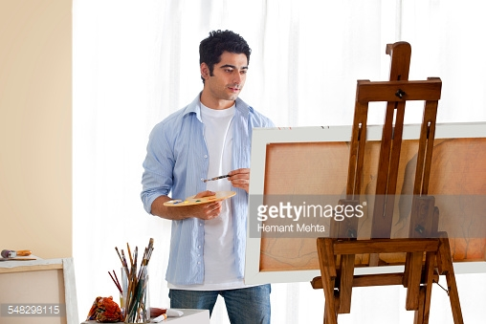 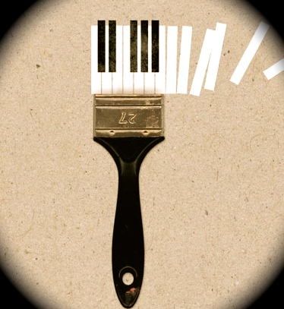

**Create in a therapeutic environment**

You are welcome to participate in our new **art and music therapy program** while you are in this period of transition. Art and music therapy will create a relaxing, therapeutic environment through painting and drawing, drumming circles, community choir, and individual listening sessions and will reduce symptoms of stress and anxiety that you may be facing. This includes weekly group therapy and/or individual therapy that will cater to your own needs. If traditional spoken therapy is not for you, try this new creative therapy and get the chance to express yourself through art and music!

**Contact Us**

Come join us!

Art and Music Therapy are offered as a statewide program in our Washington State Mental Health unit in Whatcom County, King County, and Pierce County.

Washington Locations:

* Seattle
* Tacoma
* Bellingham

You can register at:

Artandmusictherapy.wa.gov/jailreentry

Or call:

(206) 296-1234

Art and Music Therapy

500 5th Ave   
Seattle, WA 98104  
artandmusictherapy.wa.gov/jailreentry

Jail Reentry Program

Mental Health Counseling

Art & Music Therapy

## Create in a therapeutic environment

Art and Music Therapy is practiced in mental health and rehabilitation and is a mental health counseling tool for adults transitioning out of jail and prison in Washington State. These creative therapies can improve emotional, mental, and physical health through the reduction of anxiety and stress. Our clinical therapy professionals will get to know your individual needs and interests to best accommodate your lifestyle. If you have recently been released from a state or federal jail or prison, you will be able to register for art and music therapy or traditional spoken therapy/counseling. If you are interested in participating in group art and music therapy, the information is listed ahead with classes and contact information.

# About

**Art Therapy**

**Music Therapy**

*Music Therapy is a clinical use of music interventions accomplishes individualized goals within a therapeutic relationship with our credentialed music therapy professional.*

Music Therapy is offered as group therapy sessions including:

* Community Choir
* Drumming Circles
* Group Listening Activities
* Keyboarding

Individual sessions include:

* Individual keyboard lessons
* Meditative listening
* Singing lessons

*Art Therapy is a mental health method that uses art media and a creative process to reduce anxiety and foster emotional, mental health, and well-being*.

Art Therapy classes include:

* Canvas painting
* Drawing
* Sculpting
* Listening/drawing activities

Each class is offered once a week and you can register for one individual session per week.

To find more information, visit us at:

Artandmusictherapy.wa.gov/jailreentry