Program Evaluation Plan: KUGS
Mallory Dudley
Human Services and Rehabilitation
Western Washington University

Introduction KUGS 89.3 FM
KUGS-FM of Western Washington University is a student run radio station that is programmed to serve the desires of the student population. The mission of KUGS-FM is to have a diverse program of music, progressive news, and information that appeals to the student interest and to address cultural pluralism through programming. KUGS-FM offers various ways to listen to their program through radio, online streaming, and broadcasting, and appeals to a range of students. As a student run radio station, KUGS runs their programs for the student listener, and as a result of that, it is difficult to track who is listening to the station, why they are listening, and how to change their program that will appeal to a larger, more diverse audience.
Our objective was to assist KUGS in distributing a survey to gain knowledge about listenership from a sample of current WWU students. For this assessment, we sent surveys to a sample of five thousand students, and received 173 responses to find out if students are listening to KUGS and why. Our target audience is specifically Western students to find out how much of the population are listening, when they are listening and how they listen to KUGS. The results will help KUGS improve on any programming that appeals to diverse listeners, and give an idea of what people like and dislike about the radio station.
Background
Our team of program evaluators each reviewed literature of similar student run, on-campus radio stations that face similar situations with listenership, finances, and different opportunities that are offered for the students.
Brooklyn College Radio
In this study conducted by Andrea Baker, it is highlighted that Net-radio is a growing trend in college settings due to the accessibility of the Internet and the growing platform that the Internet has become for alternative music than what is played on traditional radio. Baker studied the Communication, Journalism, and Media students at Brooklyn College. Baker conducted what has been deemed a “methodological pluralism” style of research that incorporates both qualitative and quantitative measures in order to get a more realistic and all-encompassing result. Baker used three stages of measure; the first used ethnographic measures in which semi-structured interviews were conducted; the second involved a survey of 50 students from Brooklyn College that included 12 sections “(1) Demographics and psychographics; (2) Internet access; (3) Broadband and connectivity; (4) Time, space, online and offline patterns of listening; (5) Global communities and monoculture; (6) Traditional and Net-radio and the music industry; (7) Website features, archives, live concerts and side channels; (8) Music listening, purchasing and downloading; (9) Online advertising, purchases and subscriptions; (10) Interactivity; (11) Cable, satellite media and digital devices; and (12) Perceptions of media content” (Baker, 2010, p. 114); the third measure involved the interviewing of eight students and observations of them on an ad hoc basis at Brooklyn College Radio. Baker’s findings were that college youth are drawn away from traditional radio in search of more innovative music formats and the interactive capabilities of the Internet. Baker highlights that part of the appeal is that net-radio is devoid of regulation and is a low cost venture with limited barriers to entry.
This is relatable to our KUGS program evaluation in that Baker’s research makes note of the accessibility and preference for net-radio, as well as the demographics that find net-radio particularly preferable. This could be useful as KUGS looks to explore how and when students at Western are tuning in to the radio and how often web-streaming is being used.
Pilot Survey
University and college radio stations often cannot afford ratings services to help them gauge how many people are listening to their broadcast. Because of this, these radio stations tend to use university classes related to research to conduct surveys. It is useful to conduct a pilot survey prior to releasing the final survey. This allows the class conducting the research to gather the pilot results, and with the radio station, decide if the survey is obtaining the correct information to meet their needs. The survey is then adjusted, and another pilot survey is launched if needed (Sauls, 1996). This technique is useful in that the survey only gathers information that is useful to the radio station.
Funding of College Radio
Research of college and university radio stations across the country has been done to show a lack of adequate funding and resources for station programming on campus radio stations. This ongoing research is concerning the purpose of college radio that is limited by low budgets. A national survey was sent out to examine the purpose of noncommercial campus radio stations and review factors that influence the funding of these programs. The purpose of the study was to find if the factors differed between station director’s perceptions of the purpose versus the university respondents.
A pilot mailed questionnaire was send out with multiple-choice answers and a Linkert type 9-point horizontal scale was used to assess the results. A simple random sample of 415 college noncommercial radio station directors completed the survey at a response of 71.80%. The questionnaire included what is believed to be the main purpose of the radio stations: (1) is an integral part of an academic program; (2) serves as a public relations tool for the school; (3) serves the community; (4) is an alternative to commercial radio; (5) is a student training facility; (6) is an NPR affiliate; (7) is a student service; (8) is viewed by the school as an important entity; and (9) generates considerable support/underwriting (Sauls, 1995). The results were calculated by the mean, which then helped determine the most common purposes. The answers concluded to be a statistically significant difference of factors that influence funding of noncommercial radio stations.
The top choices for the station directors were: a student training ground for career enhancement, to serve the public interest, a public relations tool, part of the academic program, or an alternative to commercial radio (Sauls, 1995). The expected frequencies were then analyzed through a chi-square statistic to correlate variables and examine the expectation of perceptions for each question. As “purposes as predictors” they used “more than expected” or “fewer than expected” on each question (Sauls, 1995).
Most factors that were selected were perceived to have an influence on funding by the director’s of the university radio stations. Those perceptions differ from perception of the purpose of the noncommercial radio stations. The results reveal a combination of perceptions of purpose for the university respondents and the radio station directors. There is no significant difference between serving the public interest for the respondents and providing an alternative to commercial radio for the radio station director’s perception of the purpose.
Program evaluation design
The program evaluation team met for an informational interview with Program Manager Jamie Hoover, and AS KUGS Program Director Jordan Van Hoozer. Our meeting covered the main topics of what KUGS needed for our evaluation, as far as finding out which students are listening to the radio station. We found that KUGS really wants to expand their programs to represent all student voices, to present progressive news, and improve the diversity of the specialty shows. It is difficult, however to advertise for the radio due to limitations of advertising past the Viking Union building so it is difficult to publicize more to students. With the assistance of Christina Van Wingerden, we sent an online listenership survey, via student email consisting of twelve quantitative questions, to a sample of five thousand students who resided on campus, during the 2014-2015 school year. This sample reached non-Associated Students, to eliminate bias for those who are involved with KUGS, and extend to the average student population. A survey was the best instrument to use to reach a wide range of our target population to acquire student beliefs and opinions. Surveys are a highly effective way to receive responses when polling to a large population.
Findings
The survey, designed to find out if WWU students are listening to KUGS, consisted of twelve questions including multiple choice and write in your own answer.

Question 1:
Do you live on or off campus?
This survey was sent to students that lived on campus in the 2014-2015 school year so out of the respondents, 76% currently live off campus and 24% live on Western’s campus.
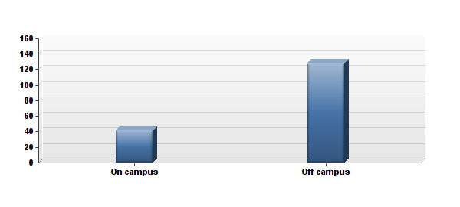
Question 2:
What is your class standing?
Only 1% of respondents are first year students, with the majority of 46% as second year students, 20% third year students, 24% fourth year students, 6% fifth year students, and 2% other (alumni, dropout, transfer student).
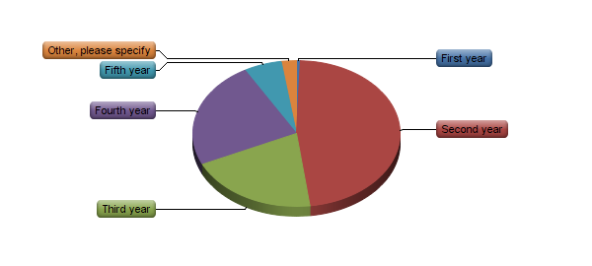
Question 3:
Have you ever listened to KUGS 89.3 FM, the WWU student run radio station?
The bar graph below visually shows 49% of respondents answered “yes” to having listened to KUGS, 42% responded “no”, 7% “Didn’t know WWU had a radio station”, and 2% were “unsure” if they have listened to KUGS.
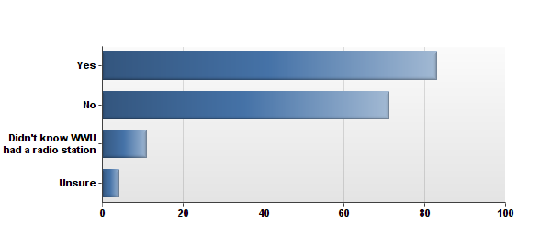

Question 4:
Do you listen to KUGS 89.3 FM now?
Results are displayed below. 55% of respondents replied “yes”, and 45% replied “no” for currently listening to KUGS.
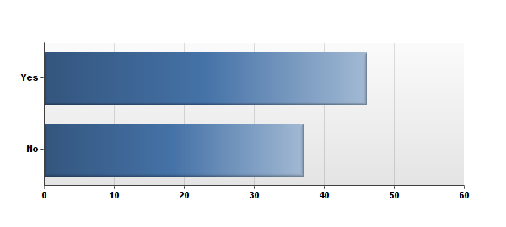
Question 5:
Please tell us why you do not listen to KUGS 89.3 FM.
According to the bar chart below, 13% of respondents “Didn’t know WWU had a radio station”, 70% “Don’t think about it”, and 17% responded with “Other (please specify).” Within the 17% “other”, five respondents replied with comments that they do not listen to radio, and three respondents said that KUGS does not play the music they like. The remaining four had other reasons for not listening to KUGS. Refer to Appendix E for “Other.”
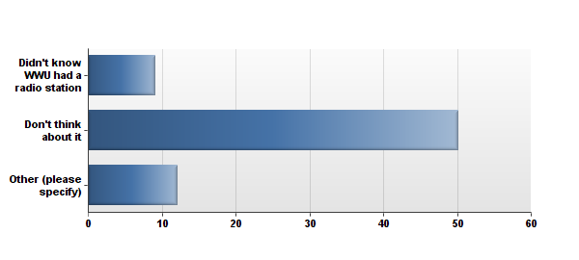
Question 6:
Please tell us why you listen to KUGS 89.3 FM.
Out of thirty-four responses for this question, 6 (17%) commented that KUGS plays “good music”, 8 (23%) said they like the “variety of music”, 7 (20%) liked to support “local radio”, and the remaining 13 respondents replied with various other reasons for listening to KUGS. Refer to appendix F to view responses.
Question 7:
How do you listen?
The pie chart below shows 78% listen by “Radio” (blue), 4% by “Broadcast” (red), 44% by “Online stream” (green), and 4% with “Other (please specify)”, (purple). Refer to appendix G.
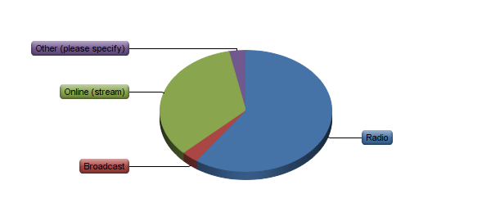
Question 8:
When do you listen/what time?
10% listen to “Morning Show”, 54% for “Music for the Masses (10am-5pm), 11% for “Evening News”, 49% for “Evening Specialty Music”, 35% for “Weekend Specialty Music”, and 14% for “If uncertain which program you listen to, please list the time.” Responses varied between listening various times and when people are in their cars. Refer to appendix H.
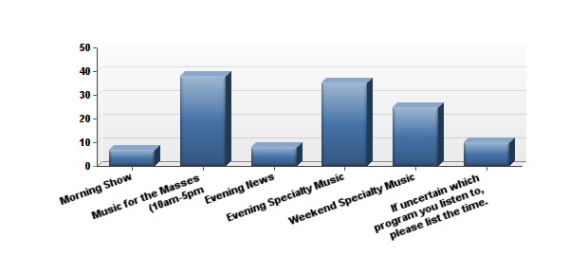

Question 9:
How often do you tune into KUGS 89.3 FM?
These results are not mutually exclusive as people responded to more than one option. 3% responded with “Daily,” 55% for “0-2 days a week,” 11% for “3-5 days a week,” 4% for “6-7 days a week”, and 28% with “Other (please specify).” Ten respondents answered that they listen randomly or occasionally, four responded that they rarely listen, and four responded that they do not listen. Refer to appendix I.
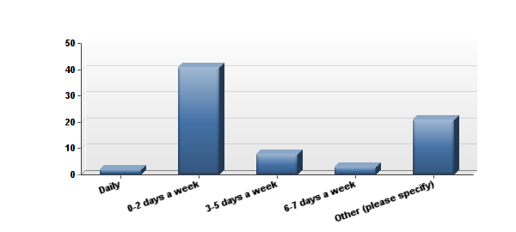

Question 10:
How did you hear about KUGS?
27% of respondents heard of KUGS through a “Tabling event,” 73% through “Word of mouth,” 19% through “Social media,” and 22% with “Other (please specify).” Responses of “other” consisted commonly of hearing of KUGS through this survey, from posters/advertising, and the info fair. Refer to appendix J.

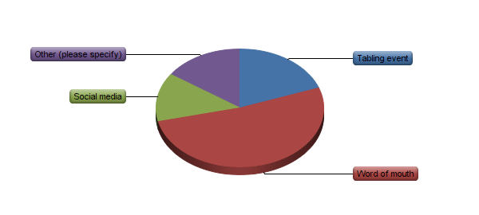

Question 11:
Do you value WWU having a college student run radio station?
72% responded “yes,” 6% responded with “no,” 20% responded “unsure” to valuing a campus radio station and 2% responded “Other (please specify).” Refer to appendix K.
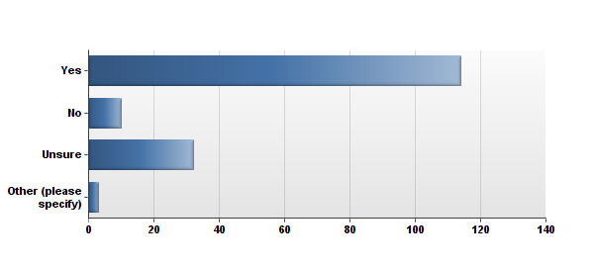
Question 12:
Do you have any suggestions for KUGS 89.3 FM?
A small sample of suggestions for KUGS consisted of similar patterns:
- More/different advertising through events and posters
- Advertising of the option of online stream
- Communication of KUGS and the DJ’s with other radio stations
Listener’s suggestions for DJ’s include less pop and indie genres. KUGS listeners asked for different music for the specialty shows such as:
- Rap/hip hop
- Throwbacks
- World music
- Salsa/Bachata
- Local Bellingham artists
- Rock/blues/metal
Refer to appendix L for written responses.
Limitations
While the KUGS survey was distributed to a sample of five thousand students who lived on campus in the 2014-2015 school year, there were limitations within the results of this study. The majority of respondents (47%) were second year students at Western and little first and third year students were represented in the results. This represented a smaller sample of Western students and does not reach the entire spectrum of possible listeners, including equal percentages of first to fifth year students. Due to missing equal portions of grade levels at Western, we do not have data that equally represents all listeners, and therefore has skewed the data. We do not know enough information about freshman, juniors, and seniors to know if they listen to KUGS more or less than sophomore, and what shows they listen to.
Recommendations
The results of the survey displayed suggestions for KUGS to give listeners what they want. Many comments from listeners showed a concern for advertising and publicity for the radio station. There are many students who simply do not know about the radio station, and have not heard much about it in their time at Western within classes, clubs, and on campus events. Stronger advertising would greatly help obtain more listeners and feedback on the programming. Although posters are limited to the Viking Union building, there could be more ways to get the word out and get people to communicate about KUGS through visual representation. As program evaluators, we do not know the specifics of what is allowed for advertising, especially if it is not allowed passed the Viking Union building. However, having the KUGS logo in the Viking Union building could help spread the word and get more supporters for the station. The results of the survey displayed positive feedback for KUGS and an appreciation for having a student run radio station that represents the student voice; consequently more students who do not know about KUGS would also be able to appreciate the station. For the programming, listeners enjoy that there is a variety of music; however there are some specific genres and artists the students believed were being left out such as rap/hip hop and throwbacks, world music, and more local Bellingham artists. When targeting a student audience that is progressive and young, there are many genres that can be beneficial, including non-mainstream genres that are tailored for the younger population.
The process of changing the programming, and considering the audience inclusion of how KUGS runs their station would include interpretive and emergent planning. As a program that is already established and in need of small changes, will benefit from alternative ways of improving programming, and also includes a diverse element and considers the social context of the KUGS objective. As improvement involves interactions and feedback from others, is essential to be flexible with decisions, and learn from new perspectives of the results of this assessment. This process is inclusive of all voices and recognizes each perspective to help KUGS meet their objectives.
Conclusion
It is important to evaluate existing programs to assess any needs within organizations and programs. With this simple assessment, KUGS has a better idea of whom their listeners are and how to appeal to college students. As a group, we learned the skills and knowledge needed to conduct a program plan and evaluation. I am more confident in my abilities as a Human Services professional and will know how to properly evaluate an existing program and know how to use rational and interpretive planning when needed. This experience with KUGS has shown me how essential evaluations are and how beneficial it can be to perform an evaluation. These evaluations can identify a need, and improve the community involvement within existing programs. Organizations might be productive and successful, but there are always gaps within services that can be difficult to identify for the organization itself. It is beneficial to see these programs with a new knowledge and a different perspective through using different rational or interpretive approaches.

References
Associated Students of Western Washington University. (n.d.). Retrieved November 27, 2015, from http://as.wwu.edu/kugs/
Baker, A. (2010). Reviewing net-only college radio: A case study of Brooklyn college radio. Journal of Radio & Audio Media, 17(1), 109-125. doi:10.1080/19376521003719409
Sauls, S. J. (1995). Factors which influence the funding of college and university noncommercial radio stations: purposes as predictors. Educational resources information center (Report No. ED410625). Retreived from http://files.eric.ed.gov/fulltext/ED410625.pdf
Sauls, S. J. (1996, September 6). Practical Applications of Survey Research at Collegeand University Radio Stations. . Retrieved from http://files.eric.ed.gov/fulltext/ED410626.pdf

Appendix A
Initial Report
Last Modified: 11/09/2015
1. Do you live on or off campus?
# | Answer |  | Response | %
1 | On campus |  | 41 | 24%
2 | Off campus |  | 128 | 76%
 | Total |  | 169 | 100%

Statistic | Value
Min Value | 1
Max Value | 2
Mean | 1.76
Variance | 0.18
Standard Deviation | 0.43
Total Responses | 169

Appendix B
2. What is your class standing?
# | Answer |  | Response | %
1 | First year |  | 1 | 1%
2 | Second year |  | 80 | 47%
3 | Third year |  | 34 | 20%
4 | Fourth year |  | 40 | 24%
5 | Fifth year |  | 10 | 6%
6 | Other, please specify |  | 4 | 2%
 | Total |  | 169 | 100%

Other, please specify
Graduate
alumni
Transfer student
Dropout

Statistic | Value
Min Value | 1
Max Value | 6
Mean | 2.94
Variance | 1.19
Standard Deviation | 1.09
Total Responses | 169

Appendix C
3. Have you ever listened to KUGS 89.3 FM, the WWU student run radio station?
# | Answer |  | Response | %
1 | Yes |  | 83 | 49%
2 | No |  | 71 | 42%
3 | Didn't know WWU had a radio station |  | 11 | 7%
4 | Unsure |  | 4 | 2%
 | Total |  | 169 | 100%

Statistic | Value
Min Value | 1
Max Value | 4
Mean | 1.62
Variance | 0.51
Standard Deviation | 0.71
Total Responses | 169

Appendix D
4. Do you listen to KUGS 89.3 FM now?
# | Answer |  | Response | %
1 | Yes |  | 46 | 55%
2 | No |  | 37 | 45%
 | Total |  | 83 | 100%

Statistic | Value
Min Value | 1
Max Value | 2
Mean | 1.45
Variance | 0.25
Standard Deviation | 0.50
Total Responses | 83

Appendix E
5. Please tell us why you do not listen to KUGS 89.3FM.

Appendix E
# | Answer |  | Response | %
1 | Didn't know WWU had a radio station |  | 9 | 13%
2 | Don't think about it |  | 50 | 70%
3 | Other (please specify) |  | 12 | 17%
 | Total |  | 71 | 100%

Other (please specify)
I listen to other stations
I don't listen to the radio
No access to a radio
Never listen to the radio
I found other ones quicker that have a music genre that I continuously enjoy. Listening to new things is fun, but usually I want the same old station.
Listen to noise, speedcore, black metal, and enka.
Never listen to radio
I don't really listen to the radio in general.
Did not know the station number
the station doesn't usually play music I like
I don't use my radio often
I have an aux cord

Statistic | Value
Min Value | 1
Max Value | 3
Mean | 2.04
Variance | 0.30
Standard Deviation | 0.55
Total Responses | 71

Appendix F
6. Please tell us why you listen to KUGS 89.3FM.
Text Response
I like to listen to KUGS because I think it is interesting that we have a radio station and I like what KUGS plays.
Great variety, I love the punk rock show.
I finally have a car, so I can listen to the station, though I also recently found out the station streams online as well. I listen because my fellow Western students run it!
I enjoy supporting student radio and I feel the programming is usually a unique surprise each time I tune in.
Variety of music -- always finding something new. Also to support my friends!
I'm a DJ on KUGS
Monday night's show "Evocative Electronic". It is seriously the best.
It's got a great range of taste, independent DJ's, and I DJ as well.
I like the wide variety.
Some good tunes in he car
I do a lot of driving and I listen to music while I drive, preferably local stations, and KUGS fits that bill.
Only clear radio station in Bellingham that doesn't have Canadian news, weather, and traffic
I listen to KUGS because it showcased a varied and interesting selection of music and other content.
Because it is the school run radio station.
I enjoy their programming a lot. They cover a broad spectrum of tastes. But I'm a DJ there, so I have a bias.
Appreciate the range of music that is played and how the station introduces new music that is a lot of time from the Pacific Northwest area
Because I'm listening to my own show as I'm doing it.
I listen to KUGS because they have some good music
They have good music.
Ari!!!
Good music
Good frequency (less static than some stations) and interesting music! Variability! No commercials!
Because it's great! And Jordan is amazing and I want to support her and KUGS
It rocks. Student run, mostly. Non commercial.
My friend is one of the DJs, and I like the variety of this station over other stations.
I am a DJ for KUGS
Music and supporting independent radio.
The station plays a plethora of music otherwise unknown to most listeners, and provides a new experience with every listen
I enjoy listening to KUGS in the evening when I am doing homework. A good background for me as I do better studying when I am listening to music.
I listen to KUGS because my car does not have an auxiliary input, and no other radio stations play anything worth giving a listen to. I can really tell how much effort goes into the selection of each track by you hard-working DJs. Keep it up.
i enjoy its music
Such diverse content. And me any my friend are DJs.
Love the unique programing and informative news.
I listen to it when I am travelling around Bellingham in my car, because it has a better signal off-campus than it does on campus, especially around Edens the signal is really bad.
I'm a DJ there!

Statistic | Value
Total Responses | 35

Appendix G
7. How do you listen?
# | Answer |  | Response | %
1 | Radio |  | 56 | 78%
2 | Broadcast |  | 3 | 4%
3 | Online (stream) |  | 32 | 44%
4 | Other (please specify) |  | 3 | 4%

Other (please specify)
CD's
Live.
I don't listen anymore

Statistic | Value
Min Value | 1
Max Value | 4
Total Responses | 72

Appendix H
8. When do you listen/what time?
# | Answer |  | Response | %
1 | Morning Show |  | 7 | 10%
2 | Music for the Masses (10am-5pm |  | 38 | 54%
3 | Evening News |  | 8 | 11%
4 | Evening Specialty Music |  | 35 | 49%
5 | Weekend Specialty Music |  | 25 | 35%
6 | If uncertain which program you listen to, please list the time. |  | 10 | 14%

Appendix H
If uncertain which program you listen to, please list the time.
When I drive
Various times, when I drive
4:00pm-10:00pm
Whenever I am in the car
Never
Late night/early morning m4tm
random times
Hard to say
I don't listen

Statistic | Value
Min Value | 1
Max Value | 6
Total Responses | 71

Appendix I
9. How often do you tune into KUGS 89.3FM?
# | Answer |  | Response | %
1 | Daily |  | 2 | 3%
2 | 0-2 days a week |  | 41 | 55%
3 | 3-5 days a week |  | 8 | 11%
4 | 6-7 days a week |  | 3 | 4%
5 | Other (please specify) |  | 21 | 28%
 | Total |  | 75 | 100%

Appendix I
Other (please specify)
Never
It's kind of sporatic ... My radio doesn't always pick it up (it's old) otherwise I'd listen more.
Rarely
Never
once in a blue moon
Sparatically
Almost never
Rarely
I don't
Whenever I'm in a car--once every few weeks...
About once a month
not often
Once every other week
Once a month
a couple times a month
random accasions
Every couple months
Rarely
not at all
once a month

Statistic | Value
Min Value | 1
Max Value | 5
Mean | 3.00
Variance | 1.84
Standard Deviation | 1.36
Total Responses | 75

Appendix J
10. How did you hear about KUGS?
# | Answer |  | Response | %
1 | Tabling event |  | 38 | 27%
2 | Word of mouth |  | 101 | 73%
3 | Social media |  | 26 | 19%
4 | Other (please specify) |  | 30 | 22%

Other (please specify)
My sister was a DJ a couple of years ago and I'd sit in with her.
I'm a volunteer!
My dad
Survey
I didn't know about it until this survey
Info Fair
poster and stumbling upon it
posters
Ex-DJ was a friend
Posters on campus
WWU Tour
Info fair
Info Fair
Campus tour
2014/15 info fair
unsure
Scrolling through radio
Browsing the radio
Red Square Info Day, friends, the stickers around campus
postings around campus
This survey too
A friend works at the station
I have a friend who DJs for KUGS
Freshman orientation 2009, association fair
Know Dj's
I have also volunteered there for 3 years.
Journalism professors
Didn't know
posters

Statistic | Value
Min Value | 1
Max Value | 4
Total Responses | 139

Appendix K
11. Do you value WWU having a college student run radio station?
# | Answer |  | Response | %
1 | Yes |  | 114 | 72%
2 | No |  | 10 | 6%
3 | Unsure |  | 32 | 20%
4 | Other (please specify) |  | 3 | 2%
 | Total |  | 159 | 100%

Other (please specify)
Never really thought about it
have never really thought about it
Yes! Kugs gives young people a local voice! And connects Wwu to the community!

Statistic | Value
Min Value | 1
Max Value | 4
Mean | 1.52
Variance | 0.77
Standard Deviation | 0.88
Total Responses | 159

Appendix L

12. Do you have any suggestions for KUGS 89.3 FM?
Text Response
Advertise the live streaming more, and encourage dorms/RAs to play the station during events to spread the word.
Play some chillstep if you dont already. Many students enjoy that for homework purpose listening.
Play better music
Different methods of advertising, more conversation about the student DJ aspect.
Nope :)
Keep rockin'!
Greater variety of music
Less histper pompusness.. more community
Create a better awareness about KGUS with more than flyers and posters
None.
Throwbacks. Throwbacks. Throwbacks.
No
Stream online!
Talk more enthusiastically please
While I understand that Music for the Masses brings listeners, I would argue that most of the people attending WWU aren't exactly "the masses" and would rather have some more interesting/unique tunes or genres being played. Things like reggae, techno, rock, jazz, etc. If someone is looking for what every radio station is playing, they are most likely just on pandora or some other streaming site, but it is my perception that the audience base would be more interested in a more defining sound. Just my $ 0.02.
I would suggest putting on more events, live shows, poster/record sales. Also I didn't know that you had a website or could stream online, I would broadcast this more.
More accessible music. It's shit about half the time, so I don't listen anymore.
Have more world music-oriented specialty shows.
Play some Salsa and Bachata music
N/A
I think the radio station does a great job already. I especially like the m4tm and having two hours of music and I enjoy the info sections as well
no
Less pop music. More Rock, Blues, Metal, etc.
n/a
I think we need a budget so that we can get more out-there music and ultimately more variety in the music library, both new and past releases, not sure where we would get that budget though.
Rock on
Would it be possible to stream from an app as opposed to just a radio or from an internet browser? I would probably be more inclined to listen to it then because of easier access to it.
Get the word out more about the station.
Advertise more on campus!
Maybe find a way to stream it?
More advertising! Also get out in the community and ask students what they would like to be on the radio more often
more publicity
More Local music, especially Bellingham artists
Keep being awesome!
Not really. All I have to say is to keep up the good work and keep broadcasting.
Have it playing in Red Square from time to time?
Nope
The one thing I strongly recommend is a hip hop show. There are no radio stations accessible to our region - at least that I know of - that play good hip hop. Students of Western Washington University, and the youth of this generation hold a strong connection to Hip Hop music. I guarantee that if you stopped every headphone-wearing student
on campus and asked what genre they are listening to, at the VERY LEAST 50 percent would reply saying hip hop. Most, if not all, public radio stations that spin hip hop music are doing the "top 40" billboard-charted corporate-style record label bulls•t, and that's all us hip-hop heads can get up here (through Canadian broadcasts). None of us have a public radio station to throw on that has a good hip hop selection - so we choose other avenues: Spotify, Apple Music, Pandora, etc. - and you subsequently lose these potential listeners to your competition. Give it a thought. Keep up the fantastic work.
KEEP IT UP! :)
More advertisement /awareness of particular shows within kugs
N/A
Those DJing should ramble less and probably not get as high.
no
Expand!
I would appreciate more current, experimental music being represented. I'm tired of hearing trite modern indie bullshit, or really dated jazz and funk with little to no middle ground (with the exception of the shows on Saturday night). There is so much happening in music currently that goes untouched by KUGS and so many passionate tastes that are marginalized by the staff of indifferent student DJs.
Upgrade the streaming quality.
Hire me! :D
More interviews and featured artists from school on the show, not just musicians either. All artists or anybody doing something new.
If possible, boost your signal strength. Additionally, inform people about the online stream, and talk to other college radio stations. Even though KUGS is a competitor in some senses to the other college radio stations, it would be really beneficial in my opinion for that communication to happen. My bf has a radio show at UW Bothell, which is why I know that you all don't communicate...at least not with UWave.
play better music!
You guys should play party music on the station after 10pm on weekends.
Remixes
Talk about social issues

Statistic | Value
Total Responses | 53

