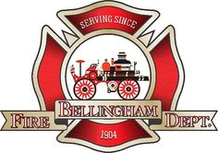

Needs Assessment: Public Awareness of the Bellingham Fire Department Community Paramedic Program

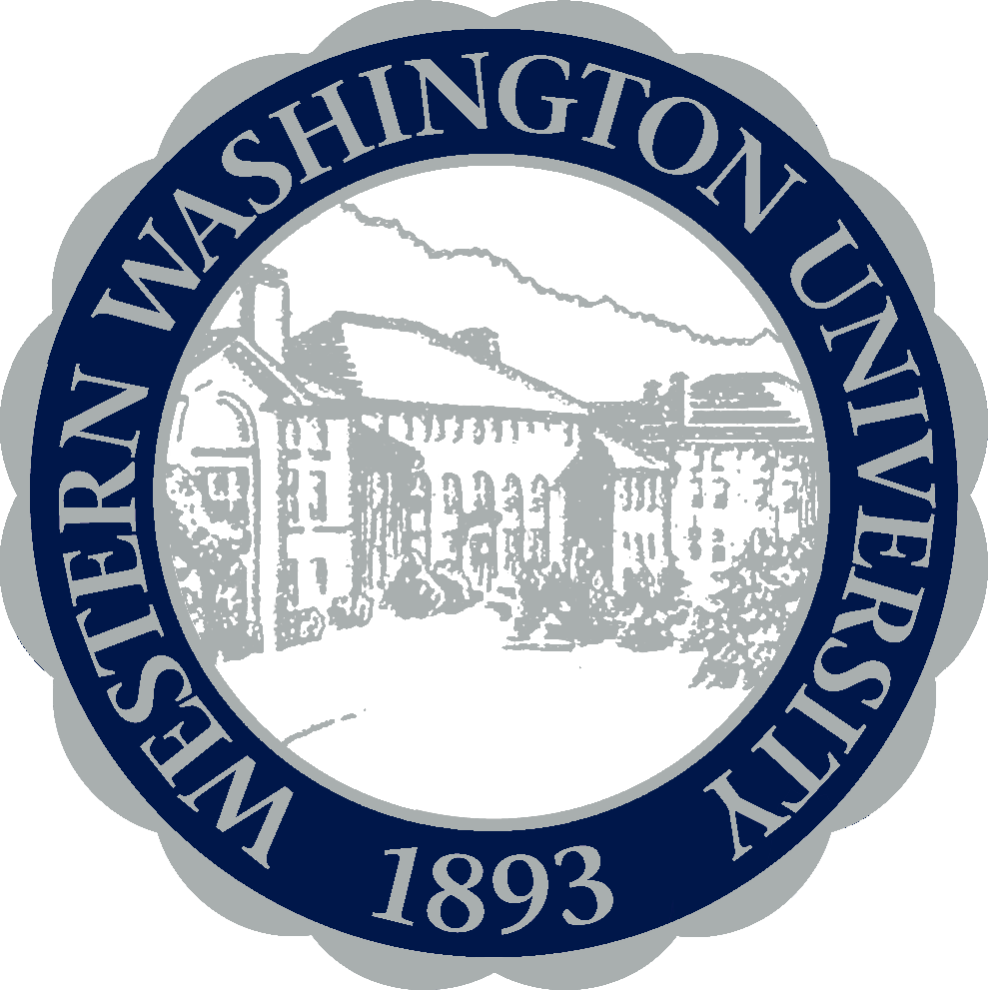

Mallory Dudley
Western Washington University
October 20, 2015
HSP 485 Program Planning & Evaluation

Community Paramedic Purposes:
The Community Paramedic program is designed to reach out to frequent 911 utilizers to improve their chronic health conditions by connecting them with needed health and social services. In October 2014, the Bellingham Fire Department received a grant to start a pilot Community Paramedic program to reduce cost of ambulance and hospital bills of chronic 911 users, and increase the health outcomes of these community members. These 911 calls are preventable, as they are usually chronic health conditions that need further medical attention. Two hundred utilizers accounted for fifteen percent of EMS (Emergency Medical Service) responses in 2014 (Bellingham Fire Department, 2015). The Community Paramedic seeks these high utilizers to propose an intervention or meeting with clients to find a strategy that would best help their conditions. Within only six months of the pilot program, the Community Paramedic was able to drop calls by 53.4% after intervening and advocating insuring better care for the patients served (BFD, 2015). It is crucial to bring awareness to the Bellingham community of how to best employ health resources, the Community Paramedic, and the EMS system.
The Target Population:
The population is tracked by finding frequent 911 utilizers on the Fire Station database. The demographic is often middle aged, low-income patients with high medical needs. The ultra-utilizers the Community Paramedic works with populations who suffer from substance abuse, mental illness, homelessness, health issues, seniors, and people with disabilities. Often, these utilizers had preventable medical conditions or low-acuity complaints that could have been handled in a non-emergent setting if patients were provided the resources and services they needed. The Community Paramedic spends time advocating for the client within the needed services and tracks them by doing in-home visits and discussing their options.
Mission statement:
“To improve patient health outcomes, and reduce the high cost of chronic EMS utilizers, through remediation and prevention.” (BFD, 2015)
Barriers:
Although the Community Paramedic pilot program has greatly reduced 911 calls in the last year, dropped EMS costs significantly, and helped better the lives of the clients, there are still many gaps in the services that need assessing. The population the Community Paramedic works with is hard to monitor, as they are often homeless or without contact information. There is a large gap with communication between clients, services, and awareness with clients and the community. New barriers will also arise as clients expand and the program becomes a health care resource or connector service for the Bellingham community. One reason this program was started was to drop 911 calls and intervene with people who did not have the needed resources. Now community awareness is what is going to help keep the 911 calls down to maintain this new program. As for future projections for the strategy, there will be a need for more Community Paramedics as the awareness is spread and the resource is being harnessed. In comparison to using 911, this will be more cost-effective and helpful to the Bellingham community if the City Council decides to continue and expand the program.
Needs Identification:
There is a large need for affordable health care, services, and treatment for the homeless and low-income population in our community. Those who use 911 and the emergency room for non-urgent medical care are not able to pay their hospital bills and use these resources for quick medical care. In reality they need treatment, medication, or housing that would be reached through a doctor or social services. They simply do not have an advocate or the ability to reach these services. Social services however do not necessarily seek these clients out in the community who have “fallen through the cracks”. The Community Paramedic steps in as an advocate for the clients and as a connector or resource tool to those who do not have a network of community health services. However, as it is incredibly hard to track clients down, it is also difficult to communicate to them and the general public how to use the Community Paramedic as a resource when it is a non-emergent situation. “Fire Departments have allowed the public to define their own emergency to utilize the 911 systems” (BFD, 2015). EMS was developed for acute medical emergencies but has now transformed into chronic care for these utilizers (BFD, 2015).
The primary stakeholders of the health care system can address this population’s needs as for medical treatment, and how it has influenced the way medical needs are handled. It is important to focus on prevention and intervention in these cases to diminish 911 calls and reach this population who needs high medical attention. In Bellingham, 70-80% of 911 calls were non-life threatening, and that can now be prevented and handled by the Community Paramedic.
Other programs in the country have discovered benefits to using this while approximately two hundred and thirty programs have been implemented across the country (Mihir, 2014). Bellingham is still in the process of reviewing the results to City Council to establish and fund a long-term program. However, with a new program it is essential to maintain it through community action and implementation.
Needs Assessment:
It is critical to make the Community Paramedic available to community members who are struggling with chronic medical needs that do not have access to assistance or aid. However, it is now necessary to transition how people think about Emergency Medical Services, and let the public know how to correctly use it. Although it is a resource readily available to anyone, there are other options. Raising awareness to the community about this program will help the public gain knowledge on the whole meaning of EMS response teams and why they are there for emergency situations only. It will also educate those about the Community Paramedic to those who do not feel that they have many options for their needs. In order to gain a public response, a focus group for the Bellingham community will be held to educate and decrease gaps within the connector services.
Key objectives:
- To inform the target population of the resources available
- To inform the public of the Community Paramedic program and EMS purposes
- Evaluate the existing program in it’s efficiency and reliability for patients
- For organizations to efficiently communicate with each other on shared clients that have needs for multiple services
- To allocate existing services for the community
Methodology:
There will be two focus groups held regarding this issue. Focus group #1 will be held at the Bellingham Fire Department for health and social services in the community that are working with the same clients as the Community Paramedic. Representatives would come from organizations such as Whatcom Alliance for Health Advancement (WAHA), Northwest Regional Council (NWRC), Opportunity Council, Interfaith and the Bellingham Police Department. This meeting would ask questions on how to better connect and communicate with services regarding shared clients that multiple organizations are working with. There will be following questions on how to raise awareness for services to be more available for clients and the public when needing medical attention. Focus group #2 will also be held in the Bellingham Fire Department for the Bellingham Community to discuss the awareness of the Community Paramedic Program and how it can reach those who need to utilize the Community Paramedic. There would be questions regarding how to better reach the general public and best serve the health needs of the community. This would address the issue of EMS and how to best avoid using it if Bellingham members are not in an emergency state. These focus groups will meet on two different occasions for an hour each.
Discussion:

The key component would be educating the general public of resources and services that they can use to improve their lifestyles and situations. Findings from this focus group would help both the public, the Community Paramedic, and other stakeholders know how to best work with each other and efficiently reach the community needs and diminish needs for frequent medical attention. I anticipate to find community needs that will have to be established in the Community Paramedic training along with the needed connections to other organizations.
Limitations:
The first focus group could be limited to only a few organization representatives due to scheduling. There will also be many limitations within the second focus group, as this will only reach a handful of community members. Raising awareness for a Community Paramedic program will be challenging, as it is still a resource that could be over utilized itself in the future. Resources and materials are limited for spreading the word to the public and reaching the targeted populations that need the information. I recommend setting a large time frame for reaching the goal of community awareness. As a new program, it will take a while to be an established resource in the Bellingham community.

References
Hallman, Tristan. (2015). Dallas fire-rescue program helps reduce 911 calls by frequent EMS users. The Dallas Morning News. Retrieved from http://www.dallasnews.com/news/metro/20150427-dallas-fire-rescue- program-helps-reduce-911-calls-by-frequent-ems-users.ece
Zaveri, Mihir. (2014). Paramedics’ house calls highlight of new healthcare approach. The Houston Chronicle. Retrieved from http://www.houstonchronicle.com/news/houston- texas/houston/article/Paramedics-house-calls-highlight-of-new-health- 5956946.php
Moore, R., Stevenson, R. (2015). Community paramedic. The Bellingham Fire
Department. Unpublished raw data

