Essay #1
Mallory Dudley
Western Washington University
HSP 455 Diversity & Social Justice

Through intersectionality, most topics of social justice, equity and equality, and institutionalized oppression all create a compounding multifaceted relationship of multiple forms of oppression. By studying institutionalized oppression and understand the difference between equity and equality, we can use the act of social justice and knowledge of intersectionality to create a more equitable society. In the Social Work Education, social justice is defined as, “based on the principle of creating a society and institutions that are based on the principles of fairness and equality through the determination of human rights; this principle also recognizes and values the worth and dignity of every human being” (Archuleta & Martell, 2015, Reamer, 1994). This definition of social justice focuses on fairness and equality, yet does not mention the idea of equity. In an elementary education guide they define equality as, “ every human being’s absolute and equal right to common dignity and parity of esteem and entitlement to access the benefits of society in equal terms” (Mistry & Sood, 2014). “Equity is where every human being has a right to benefit from the outcomes of society on the basis of fairness and according to need” (Mistry & Sood, 2014).
To understand our lack of equality and equity in our society, it is important to understand how people are oppressed and in what ways they are oppressed. OpenSource defined institutionalized oppression as “The ways in which history, culture, ideology, public policies, institutional practices, and personal behaviors and beliefs interact to maintain a hierarchy – based on race, class, gender, sexuality, and/or other group identities – that allows the privileges associated with the dominant group and the disadvantages associated with the oppressed, targeted, or marginalized group to endure and adapt over time” (OpenSource). This oppression can take overlapping, multiple forms of identity that intersect with each other. “Intersectionality promotes an understanding of human beings as shaped by the interaction for different social locations (e.g., ‘race’/ethnicity, Indigeneity, gender, class, sexuality, geography, age, disability/ability, migration status, religion). These interactions occur within a context of connected systems and structures of power (e.g., laws, policies, state governments and other political and economic unions, religious institutions, media). Through such processes, interdependent forms of privilege and oppression shaped by colonialism, imperialism, racism, homophobia, ableism and patriarchy are created” (Hankivsky, 2014).
Metaphors can be a beneficial way to understand social justice concepts. A musical chairs metaphor for social justice is used for an international focus on resources (cbmjustice blogspot, 2012). The game of musical chairs where there is always one less chair than there are people is the metaphor for resources. The chairs represent the lack of resources for everybody, or “scarce resources” that make people have to fight for the chairs. This metaphor demonstrates the competition between our people and our Nations over resources such as land, oil, money, education etc. The act of social justice would be a fight for equality and equity, so that every person has a chair as a means of needed resources. When looking at it from an oppressed economic standpoint, the poor and working class would be the ones competing for the chairs while the wealthy get to play the music, as they are not even competing for resources. This metaphor can represent many forms of oppression while it also explains our world today, and more importantly the poorly distributed wealth and resources that makes our society inequitable.
With the idea of intersectionality, metaphors can be visual and represent spatial/locational forms of how identities interweave with each other. The idea of intersectionality, using a spatial and locational metaphor related to driving, Woods creates the picture of driving on a road (Woods, 2012). She describes it as “multiple intersections” that often cross each other. With traditional approaches to identity they do not consider intersectionality yet think of it as individual and separated. One way to represent this is how traffic is the divider. It stops people from turning into a lane. Individuals stopped at a stop light “turn ‘right’ into their gender, ‘left’ into their ethnicity, or ‘straight’ into their sexuality…instead, we should envision ‘multiple intersections’ that often cross each other, creating complex crossroads where two, three, or more of these routes may meet in overlapping dimensions” (Woods, 2012). This physical spatial and locational concept of intersectionality can demonstrate how many different roads individuals are connected to. Each road/lane represents a different form of an identity. However, the traffic lights and traffic laws represent the multiple forms of oppression that makes it hard to reach certain identities. This idea can relate to an individual’s multiple forms of oppression that society has created (traffic laws) that oppress certain identities in multiple ways right at the ‘intersection’.
Institutionalized oppression

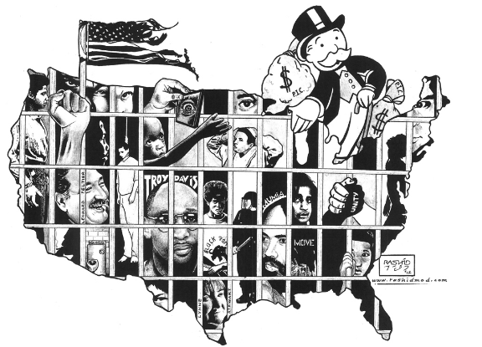
http://uprootingcriminology.org/wp-content/uploads/2014/12/prison-abolition.png
This image represents the reality of our country. With our history of teaching about liberty and freedom, but institutionally controlling marginalized identities throughout our history through our practices, public policies, attitudes and beliefs, and to marginalize anyone who is not in the dominant, majority identity groups regarding race, gender, sexual orientation, socioeconomic status, etc. This picture truly represents our criminal justice system and all of our systems and levels of power and oppression. These bars literally represent all of the “locked up,” marginalized identities, primarily poor people of color. The monopoly symbol, Rich Uncle Pennybags represents our profitable systems of imprisonment, the corruption of private prisons, and our unequal distribution of wealth. It is clear that Rich Uncle Pennybags is not behind bars as he displays a dominant identity of power and wealth. Although or systems of oppression have changed forms, it is institutionalized and a product of our society.
Equity versus Equality

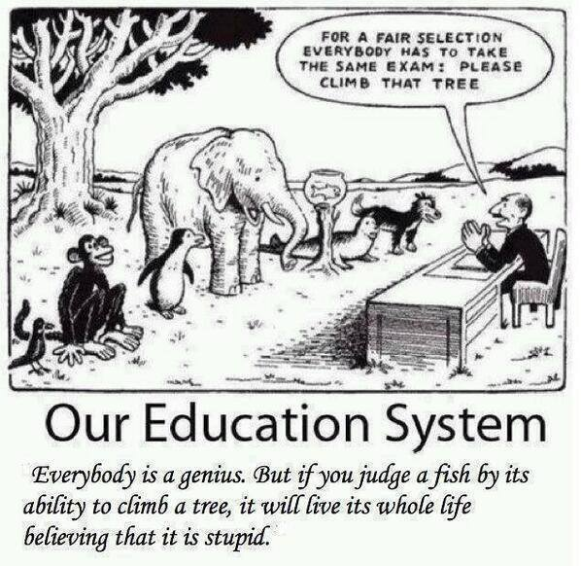

http://www.workplacetrainers.com.au/workplace-training-news/equality-vs-equity/
This image of equity and equality is very true within our education system. The entire system of schools through teachers, tests, and curriculum, the students are expected to perform the same equal tests and use the same materials. However, this is extremely harmful to expect the same from every child when every student has different needs and accommodations to help them learn and do their best. Our American education system does not acknowledge the need for equity with diverse student populations. Within my personal life growing up with our current education system, I was not granted the tools I needed to succeed in class with having some form of ADHD, and not even recognizing that I had that. I felt like the fish my whole life by believing I was stupid. I was treated the same as my peers and expected to come up with the same results with the same materials.
With all of these institutions and societal structures, they are all created to benefit dominant identities. These harmful ideologies of dominance with race, gender, sexual orientation, and socioeconomic status has targeted those who do not have privilege or dominant identities that fit with the social and societal structure of living. It is incredibly important to understand the idea of intersectionality and how individuals carry multiple identities, and how all of our identities interweave into our societal systems of oppression.

References
Archuleta, A., Teasley, Martell. (2015). A review of social justice and diversity content in diversity course syllabi. Social Work Education: The International Journal. 34:6, 607- 622, DOI: 10.1080/02615479.2015.1037828
Equality vs. equity | Professional Workplace Trainers. (2015). Retrieved February 02, 2016, from http://www.workplacetrainers.com.au/workplace-training-news/equality-vs-equity/
Mistry, M., Sood. K. (2014). Permeating the social justice ideals of equality and equity within the context of early years: challenges for leadership in multi-cultural and mono-cultural primary schools. Education 3-13: International Journal of Primary, Elementary and Early Years Education. 43(5), DOI: 10.1080/03004279.2013.837944
Race Archives - Uprooting Criminology : A Reasoned Plot. (2015). Retrieved February 03, 2016, from http://uprootingcriminology.org/tag/race/
Social Justice: A Musical Chairs Metaphor [Web log post]. Live Simply, Give Generously, Practice Hospitality...Act Justly (2012, February 20). Retrieved February 2, 2016, from http://cbmjustice.blogspot.com/2012/02/social-justice-musical-chairs-metaphor.html
Woods, C.S. (2012). (Im)mobile metaphors toward an intersectional rhetorical history. University of Nebraska – Lincoln, Department of Communication Studies. Retrieved from http://digitalcommons.unl.edu/cgi/viewcontent.cgi?article=1042&context=commst udiespapers

